**Python DL Lesson 4**

**Chandrasekhar pentakota**

**16267781**

**Question 1:**

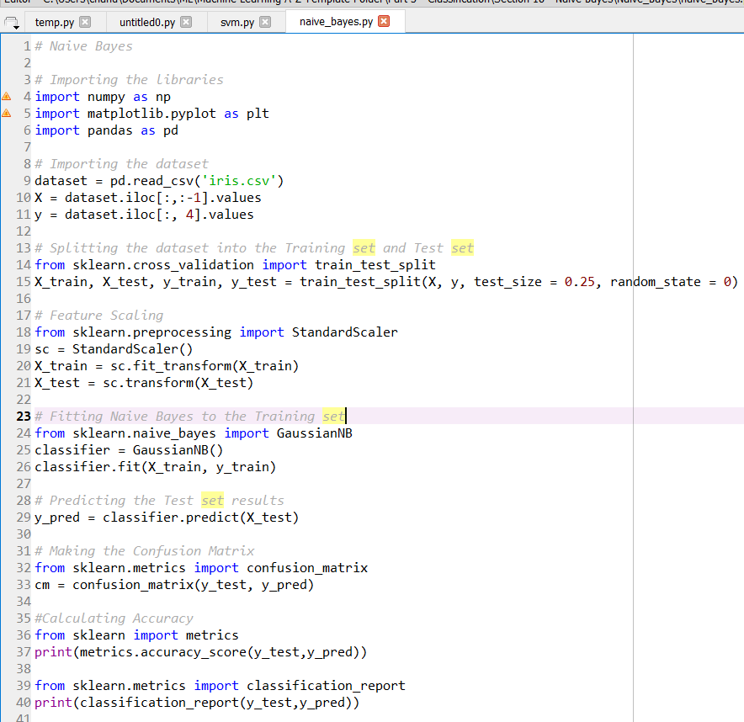

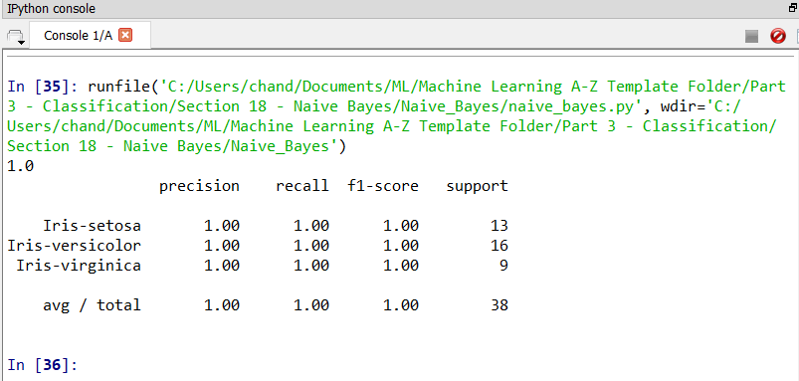

**Question 2:**

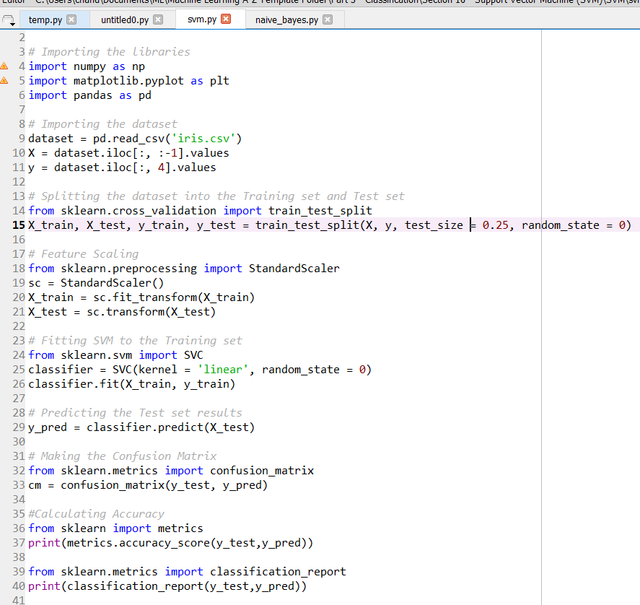

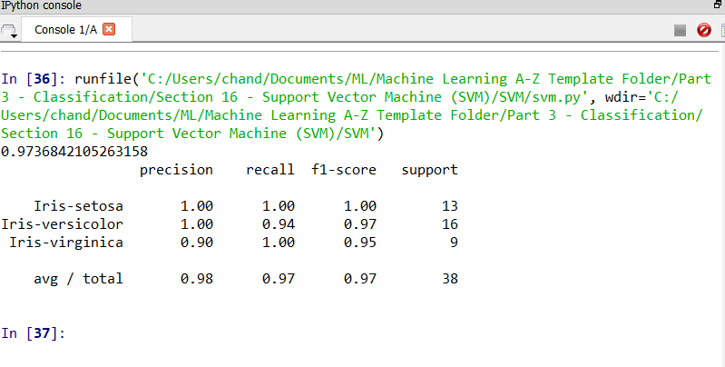

**Question 3:**

Naïve Bayes has got 100% accuracy that means it predicted correctly for all the test data. Where as Support Vector Machine has got 97% accuracy compared to the other model.

Also calculated all the three values for two model’s precision, accuracy, recall and fscore.